Лабораторна робота №1.
“ Знайомство з мовою програмування Prolog “

Для вибраної вами сім’ї побудувати родинне дерево (граф). Вершинами графу є імена членів родини, дуги-відносини ( батько-дитина , мати-дитина ). .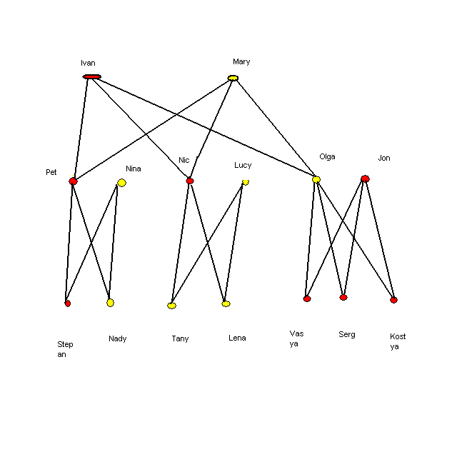
Текст програми , що описує вищенаведену родину

domains
s=string
database-ss
b(s,s)

predicates

nondeterm parent(s,s)
nondeterm man(s)
nondeterm woman(s)
nondeterm father(s,s)
nondeterm mother(s,s)
nondeterm son(s,s)
nondeterm doughter(s,s)
nondeterm g_father(s,s)
nondeterm g_mother(s,s)
nondeterm g_son(s,s)
nondeterm g_doughter(s,s)
nondeterm brother(s,s)
nondeterm sister(s,s)
nondeterm is_brother(s,s)
nondeterm dob(s,s)
nondeterm menu
nondeterm m(integer)

clauses

parent("Ivan","Pet").
parent("Ivan","Nic").
parent("Ivan","Olga").
parent("Mary","Pet").
parent("Mary","Nic").
parent("Mary","Olga").
parent("Pet","Stepan").
parent("Pet","Nady").
parent("Nina","Stepan").
parent("Nina","Nady").
parent("Nic","Tany").
parent("Nic","Lena").
parent("Lucy","Tany").
parent("Lucy","Lena").
parent("Olga","Vasya").
parent("Olga","Serg").
parent("Olga","Kostya").
parent("Jon","Vasya").
parent("Jon","Serg").
parent("Jon","Kostya").

man("Ivan").
man("Pet").
man("Nic").
man("Jon").
man("Stepan").
man("Vasya").
man("Serg").
man("Kostya").

woman("Mary").
woman("Nina").
woman("Lucy").
woman("Olga").
woman("Nady").
woman("Tany").
woman("Lena").

father(X,Y):- parent(X,Y), man(X).

mother(X,Y):- parent(X,Y), woman(X).

son(X,Y):- parent(Y,X), man(X).

doughter(X,Y):-parent(Y,X), woman(X).

g_father(X,Y):-parent(X,Z), parent(Z,Y), man(X).

g_mother(X,Y):-parent(X,Z), parent(Z,Y), woman(X).

g_son(X,Y):-parent(Z,X), parent(Y,Z), man(X).

g_doughter(X,Y):-parent(Z,X), parent(Y,Z), woman(X).

brother(X,Y):- parent(Z,X), parent(Z,Y), man(X),X<>Y.

sister(X,Y):-parent(Z,X), parent(Z,Y), woman(X),X<>Y.

is_brother(X,Y):-brother(X1,Y1),dob(X1,Y1),fail;

b(X,Y).

dob(X,Y):-b(X,Y),!;

assert(b(X,Y)).

menu:- write(" 1-Found father"),nl,
write(" 2-Found mother"),nl,
write(" 3-Found son"),nl,
write(" 4-Found brother"),nl,
write(" 5-Found sister"),nl,
write(" 6-Found doughter"),nl,
write(" 7-Found g_father"),nl,
write(" 8-Found g_mother"),nl,
write(" 9-Found g_son"),nl,
write(" 10-Found g_doughter"),nl,

readint(X),

m(X).

m(1):-write(" Input name the man"),nl,
readln(X),
father(X,Y),
write(" The "),
write(X),
write(" father ",Y), nl,
fail;
readln(_),
menu.

m(2):-write(" Input name the woman"),nl,
readln(X),
mother(X,Y),
write(" The "),
write(X),
write(" mother ",Y), nl,
fail;
readln(_),
menu.
m(3):-write(" Input name the man"),nl,
readln(X),
son(X,Y),
write(" The "),
write(X),
write(" son ",Y), nl,
fail;
readln(_),
menu.
m(4):-write(" Input name the man"),nl,
readln(X),
brother(X,Y),
write(" The "),
write(X),
write(" brother ",Y), nl,
fail;
readln(_),
menu.
m(5):-write(" Input name the woman"),nl,
readln(X),
sister(X,Y),
write(" The "),
write(X),
write(" sister ",Y), nl,
fail;
readln(_),
menu.
m(6):-write(" Input name the doughter"),nl,
readln(X),
doughter(X,Y),
write(" The "),
write(X),
write(" doughter ",Y), nl,
fail;
readln(_),
menu.
m(7):-write(" Input name the man"),nl,
readln(X),
g_father(X,Y),
write(" The "),
write(X),
write(" g_father ",Y), nl,
fail;
readln(_),
menu.
m(8):-write(" Input name the woman"),nl,
readln(X),
g_mother(X,Y),
write(" The "),
write(X),
write(" g_mother ",Y), nl,
fail;
readln(_),
menu.
m(9):-write(" Input name the man"),nl,
readln(X),
g_son(X,Y),
write(" The "),
write(X),
write(" g_son ",Y), nl,
fail;
readln(_),
menu.
m(10):-write(" Input name the woman"),nl,
readln(X),
g_doughter(X,Y),
write(" The "),
write(X),
write(" g_doughter ",Y), nl,
fail;
readln(_),

